8.21: a) Taking 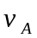 and 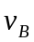 to be magnitudes, conservation of momentum is expressed as 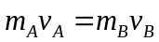, so 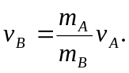
b) 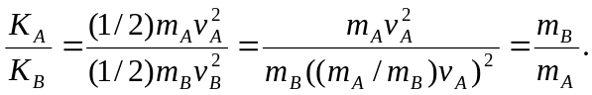

(This result may be obtained using the result of Exercise 8.3.)

